PACKAGING SPECIFICATIONS FOR IDAHOAN® WEST CREEK
REAL MASHED POTATOES
Item #: 0679550806
Issued: February 20, 2026
Supersedes: December 5, 2025

I. PRODUCT DESCRIPTION
Idahoan® West Creek REAL Mashed Potatoes are processed from sound, well peeled and trimmed 100% Idaho® Potatoes. The product complies with the provisions of the Federal Food, Drug and Cosmetic Act and Amendments.

II. INGREDIENTS
Idaho® potatoes, salt, sunflower oil, nonfat dry milk, mono- and diglycerides, calcium stearoyl lactylate, natural flavor, spice, turmeric (color), riboflavin (color). Freshness preserved by sodium acid pyrophosphate, sodium bisulfite, citric acid and mixed tocopherols.

III. NUTRITION
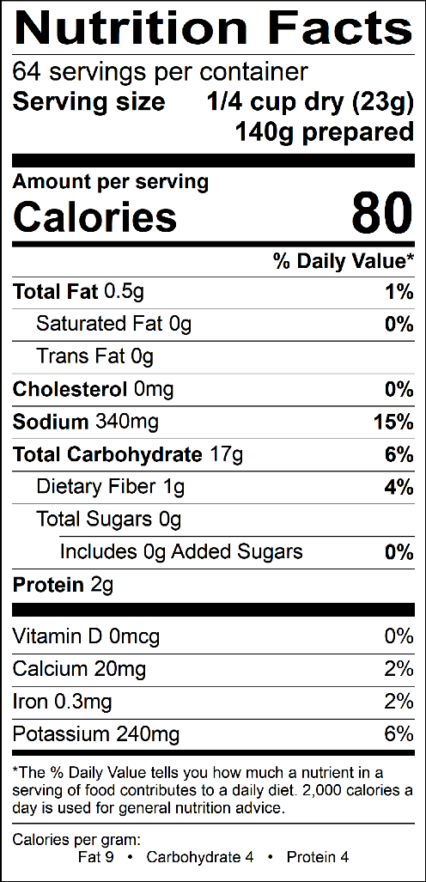

IV. FINISHED PRODUCT REQUIREMENTS

- Potato REAL see Specification #2200002

- Packaged Product
Physical & Chemical Attributes | LSL | Target | USL
Moisture |  |  | 9.0%
Salt | 3.3% | 3.5% | 3.8%
Metal Ferrous (mm)  NonFerrous (mm)  Stainless (mm) |  |  | 2  2  2.5
Foreign Material | None Detected

Microbiological Attributes | LSL | Target | USL
Standard Plate Count/g |  |  | 50,000
Coliform/g |  |  | 50
Yeast and Mold/g |  |  | 100

C. Preparation
1. Control is prepared with 737 g potatoes (#2200002).
2. Add 1 gallon of boiling water to a 6” deep ½ size steam table pan.
3. Add potatoes and seasoning all at once and stir to wet all potatoes. Let stand one minute.
4. Mix well and evaluate.

D. Prepared Product
1. Color – typical, cooked, rich, potato color ranging from cream to creamy yellow. No objectionable darkening 2 hours after preparation.
2. Texture – typical, creamy, fluffy, mashed potato texture-free from gumminess and pastiness.
3. Flavor and Aroma – normal, cooked, buttery, potato flavor and aroma. Free from objectionable foreign flavors and odors.

V. PACKAGING

- Components

Components | LSL | Declared Weight | USL
Potatoes #2200002 | 1455 | 1470 | 1485
Finished Product #550806 | 1455 | 1470 | 1485

- Packaging
Product is packaged in a paperboard gable top carton. Net weight per carton is 3.24 lbs. (1470 grams), 6 cartons per case.

C. Carton and Case Condition
1. Date codes legible and correctly positioned on carton and case
2. Cartons must be completely sealed
3. No crushed or twisted cartons or cases
4. Case tape must completely seal case

VI. SHELF LIFE & STORAGE INFORMATION
The shelf life is approximately 12 months from date of packaging code (imprinted on the package), when stored away from direct heat, in a cool, dry location, away from strong contaminating odors. Storage conditions should not exceed 80°F and 60% R.H.

VII. ALLERGENS
US – Milk INTERNATIONAL – Milk, Sulfites

VIII. CERTIFICATION
Dairy Kosher

IX. SAMPLE DATE CODING
1096 LWA 15:68

